Internal DSL

📌 Definition:
# Source: AI Source: Provided by: [Data Path: Persons Table -> ID Column: 1, Name_En Column: Motasem Essam] -> From: [Chatgpt (GPT‑5 Mini)] on [12/9/2025]
An Internal DSL is a domain-specific language built inside an existing general-purpose programming language.

🧠 Simple idea:
# Source: AI Source: Provided by: [Data Path: Persons Table -> ID Column: 1, Name_En Column: Motasem Essam] -> From: [Chatgpt (GPT‑5 Mini)] on [12/9/2025]
Internal DSL = A special mini-language inside another language

🔍 Key characteristics:
# Source: AI Source: Provided by: [Data Path: Persons Table -> ID Column: 1, Name_En Column: Motasem Essam] -> From: [Chatgpt (GPT‑5 Mini)] on [12/9/2025]
- ✅ Built using an existing language (like Python, Java)
- ✅ Uses the syntax of the host language
- ✅ Easier to create and maintain
- ❌ Limited by the host language

🧩 Example (Python Internal DSL style):
# Source: AI Source: Provided by: [Data Path: Persons Table -> ID Column: 1, Name_En Column: Motasem Essam] -> From: [Chatgpt (GPT‑5 Mini)] on [12/9/2025]
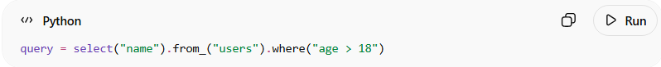
query = select("name").from_("users").where("age > 18")
👉 This looks like a mini-language for querying data, but it's actually Python code.

⚙️ How it works:
# Source: AI Source: Provided by: [Data Path: Persons Table -> ID Column: 1, Name_En Column: Motasem Essam] -> From: [Chatgpt (GPT‑5 Mini)] on [12/9/2025]
- Use a general-purpose language
- Create functions/classes to mimic a specific domain
- Write code that looks like a specialized language

🧩 Real-world examples:
# Source: AI Source: Provided by: [Data Path: Persons Table -> ID Column: 1, Name_En Column: Motasem Essam] -> From: [Chatgpt (GPT‑5 Mini)] on [12/9/2025]
- SQL-like libraries inside Python (e.g., ORM tools)
- Testing frameworks (like behavior-style tests)
- Configuration APIs

🆚 Internal vs External DSL
# Source: AI Source: Provided by: [Data Path: Persons Table -> ID Column: 1, Name_En Column: Motasem Essam] -> From: [Chatgpt (GPT‑5 Mini)] on [12/9/2025]
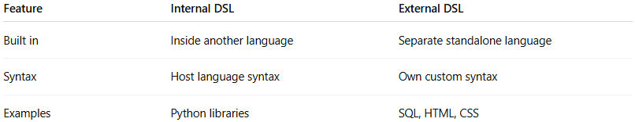
Feature | Internal DSL | External DSL
Built in | Inside another language | Separate standalone language
Syntax | Host language syntax | Own custom syntax
Examples | Python libraries | SQL, HTML, CSS

🎯 Summary:
# Source: AI Source: Provided by: [Data Path: Persons Table -> ID Column: 1, Name_En Column: Motasem Essam] -> From: [Chatgpt (GPT‑5 Mini)] on [12/9/2025]
Internal DSLs are specialized mini-languages created within general-purpose languages to make specific tasks easier and more readable.

